R. Reports Menu: 8. Cash Requirement Report

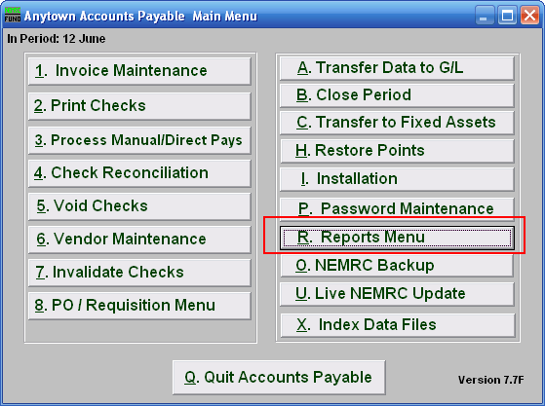
Click on “R. Reports Menu” from the Main Menu and the following menu will appear:
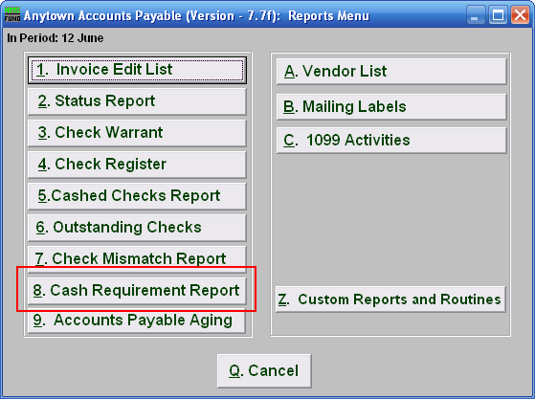
Click on “8. Cash Requirement Report” and the following window will appear:
Cash Requirement Report

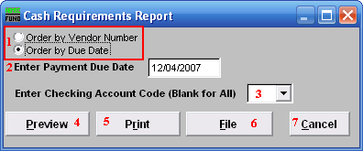
- Order by Vendor Number OR Order by Due Date: Select which order to report the data in.

- Enter Payment Due Date: Enter the payment date for which the evaluation of cash requirements will be made when ordered by due date.

- Enter Checking Account Code (Blank for All): Select the checking account code to report as set up in Installation or leave this field empty to report for all

- Preview: Click this button to preview. Refer to GENERAL PREVIEW for more information.

- Print: Click this button to print. Refer to GENERAL PRINTING for more information.

- File: Click this button to save on this computer. Refer to GENERAL FILE for more information.

- Cancel: Click “Cancel” to cancel and return to the previous screen.

